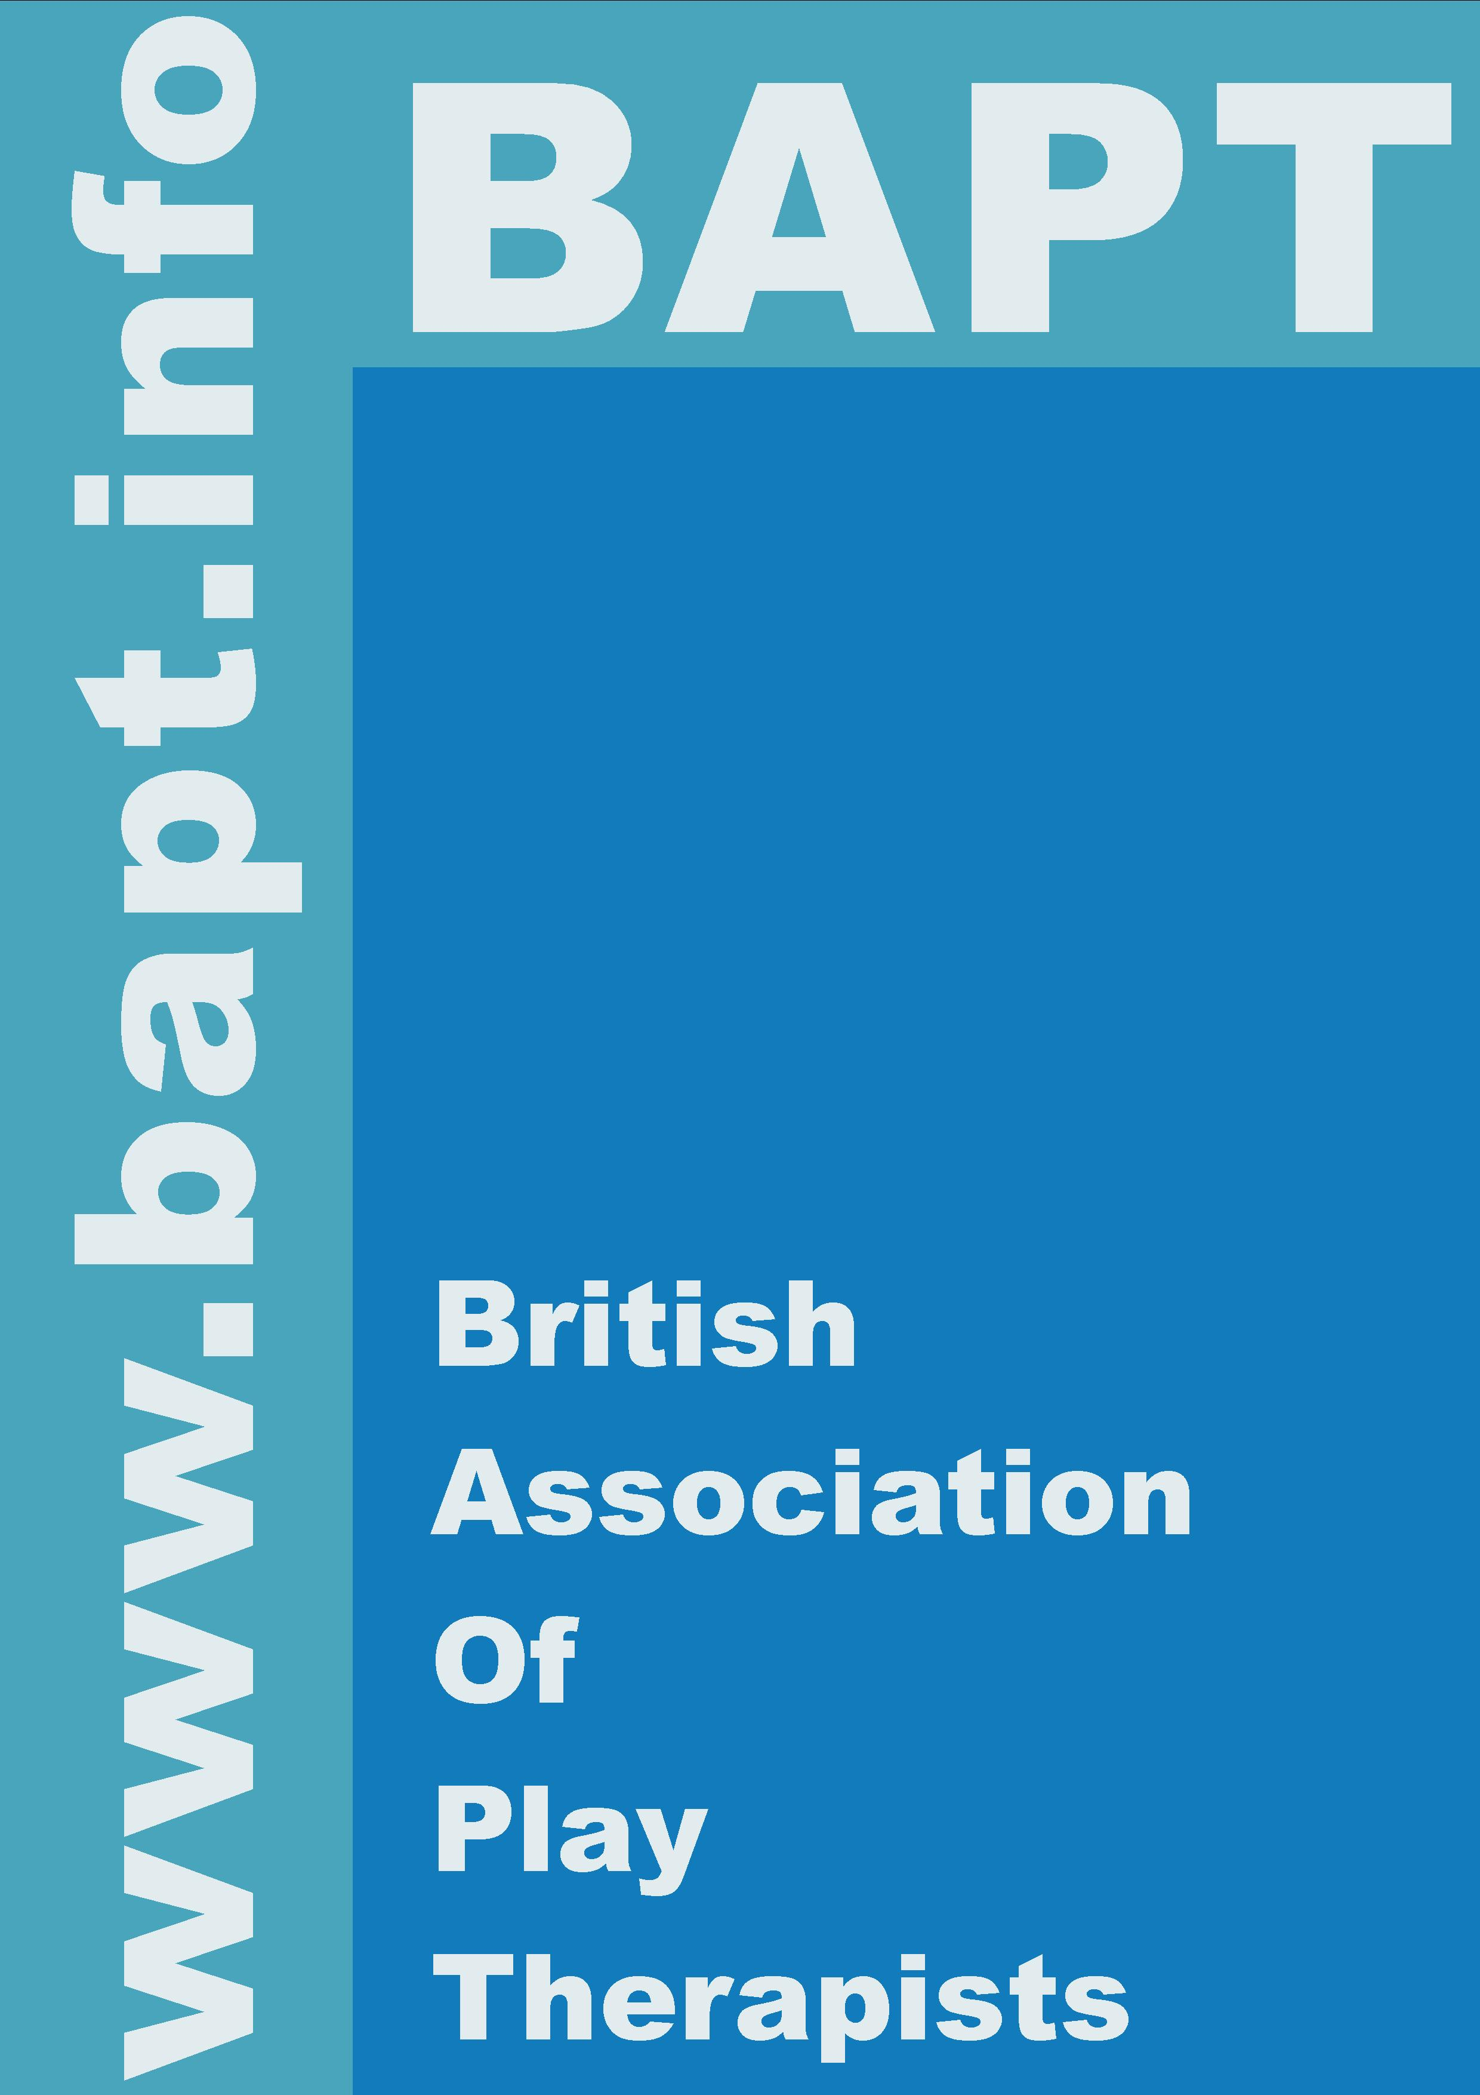
British Association of Play Therapists

Portfolio Application for Full Membership for Overseas Applicants.

LETTER OF COMPARABILITY: UK NARIC

You will need to supply a letter of comparability from the UK National
Academic Recognition Information Centre in order to validate your training.

UK NARIC is the national agency for providing this service on behalf of the Department for Education and Skills [DfES]. They are the sole official
information provider on the comparability of international qualifications from over 180 countries.

UK NARIC services can provide essential help in your progression towards employment and further study in the UK. Their guidance will better help you to identify the best options and choices for employment, study and professional status in line with UK requirements for overseas applicants. Look at the NARIC Recognition and Evaluation Service section which recognises international awards and provides clear indications of the comparable level of your qualifications from another country.

As a starting point visit their web site www.naric.org.uk
or write to:

UK Naric,
Oriel House,
Oriel Road,
Cheltenham,
GLOS. GL50 1XP.

