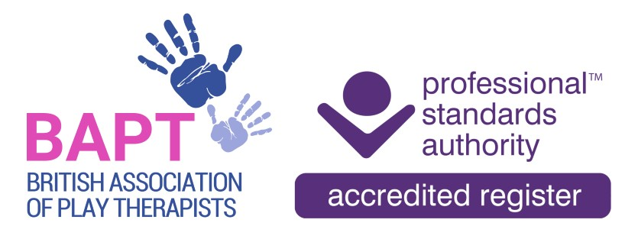

Equality & Diversity Monitoring Questionnaire

1. Gender:
Please tick as appropriate

Male |  |  | Female
Intersex |  |  | Non-Binary
Prefer to Self-Describe |  |  | Prefer not to say
Other

Is the gender you identify with the same as your gender registered at birth?
Please tick as appropriate:

Yes |  |  | No
Prefer not to say

2. Age:
Please tick as appropriate:

Under 25 |  |  | 25-34
35-44 |  |  | 45-54
55-64 |  |  | 65 or above
Prefer not to say

3. What is your ethnicity? Ethnic origin is not about nationality, place of birth or citizenship. It is about the group to which you perceive you belong.
Please tick as appropriate:

White |  |  | Black/African/Caribbean/Black British
Asian/Asian British |  |  | Mixed/Multiple ethnic groups
Prefer not to say |  |  | Other

4. What is your ethnicity? Ethnic origin is not about nationality, place of birth or citizenship. It is about the group to which you perceive you belong.
Please tick as appropriate:

African |  |  | Bangladeshi
British |  |  | Caribbean
Chinese |  |  | English
Gypsy or Irish Traveller |  |  | Indian
Northern Irish |  |  | Pakistani
Scottish |  |  | Welsh
Prefer not to say |  |  | Other

5. What is your sexual orientation?
Please tick as appropriate:

Heterosexual |  |  | Gay
Bisexual |  |  | Asexual
Lesbian |  |  | Pansexual
Undecided |  |  | Prefer not to say
Other

6. Disability
Please tick as appropriate:

Yes |  |  | No
Prefer not to say

7. What is your religious affiliation? My religious beliefs fall within the following category:
Please tick as appropriate:

No religion or belief |  |  | Buddhist
Catholic |  |  | Christian
Hindu |  |  | Jewish
Muslim |  |  | Protestant
Rastafarian |  |  | Sikh
Other |  |  | Prefer not to say

In July 2023 the PSA introduced the new Standard Nine - Equality, Diversity and Inclusion (EDI) Standard to its Standards for Accredited Registers.

BAPT demonstrates its commitment to equality, diversity and inclusion and ensures that its processes are fair and free from unfair discrimination.
a) BAPT’s regulatory functions are underpinned by fairness and equity of access to registrants and service users.
c) BAPT works to promote and enhance EDI by seeking to understand and act on issues affecting the roles registered and service users.

