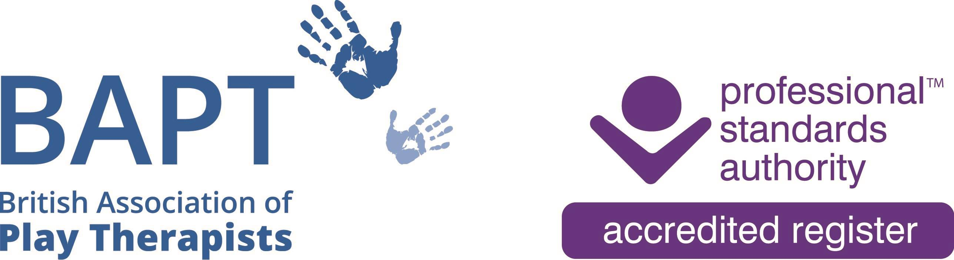 | The British Association of Play Therapists
 |  |  | Tel: | 07955 204068
 |  |  | Email: | info@bapt.uk.com

BAPT Associate Application Form



This form has been designed to ensure that the BAPT Membership Sub-Committee obtain all the information they need to reach the correct decision. By carefully answering each question you will avoid the delay which occurs when we have to ask for information which has been omitted. A £10 administrative fee is required to process all applications.

Q1 | Surname
 | First Names
 | Title
 | Date of Birth |  |  |  |  |  | Membership No
 |  |  |  |  |  |  | (Present and/or Past)
 | Previous Surname, if any

Q2 | Address
 | Postcode

Telephone:
Home: |  | Work

Email: | Home: |  | Work

Q3 | Is this the first application you have ever made to BAPT for any type of membership? |  | Yes |  |  | No
Q4 | DECLARATION FOR ASSOCIATE APPLICANT
I CONFIRM THAT:

- I do not have a criminal record that may prejudice the interests of children.
- I have not been dismissed from employment on the grounds of professional misconduct.
- I have not been refused membership of a professional body or register in a related field on the grounds of professional misconduct.
- I understand that being an Associate of the British Association of Play Therapists cannot, in any circumstances, be used as a qualification to practise and agree not to misrepresent my status as an Associate of BAPT.
- The information detailed in this Associate application form is true to the best of my knowledge and does not contain any false or misleading information.

Your Signature:
Your Full Name:
Date:

FEE PAYMENT

- Annual fee £55 – Membership year for ALL members is 1st October to 30th September – if you are applying after 1st April then a 50% reduction in fee applies.

- Administration Fee £10 - a one off fee to process this application.

JOURNAL SUBSCRIPTION

The British Journal of Play Therapy is published annually by the British Association of Play Therapists and encourages contributions from a variety of research traditions. The British Journal of Play Therapy is pluralist in orientation, recognising the value of qualitative, quantitative and mixed method strategies of inquiry.

- I would like to include Journal Subscription and have added £15 to my payment. (£25 for overseas Associates/ £25 for UK Organisations to receive 2 copies)

Total fee I am paying £

Payment of Fee

Payments to be made directly to the following account; please ensure your full name and/or membership number, if an existing member, are used as the reference for this payment.

HSBC
Payee : British Association of Play Therapists
Sort Code: 40-30-24
Account Number: 41808591
Reference: Your Name – Membership Number

