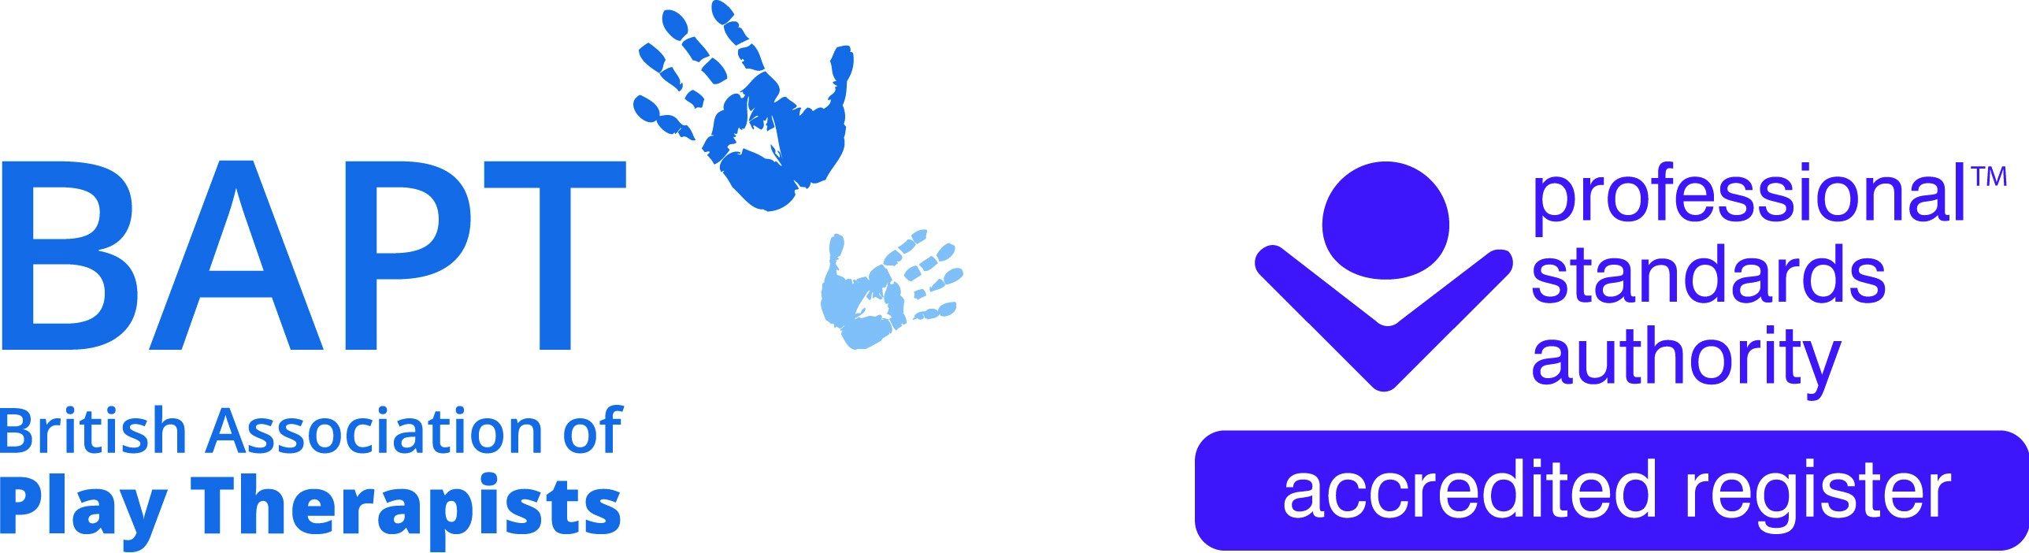 | The British Association of Play Therapists
 |  |  | Tel: | 07955 204068
 |  |  | Email: | info@bapt.uk.com

Application for FULL NQPT Membership
(BAPT Student)



This form has been designed to ensure that the BAPT Membership Sub-Committee obtain all the information they need to reach the correct decision. By carefully answering each question you will avoid the delay which occurs when we have to ask for information which has been omitted.

Q1 | Surname:
 | First Name(s):
 | Title:
 | Date of Birth: |  |  |  |  |  | Membership No:
 | Previous Surname, if any:

Q2 | Address
 | Postcode

Telephone:
Home: |  | Work

Email: | Home: |  | Work

 | Q3 | Do you possess an up-to-date and clear DBS Enhanced Disclosure? |  |  |  | Yes |  |  | No
 | Please send a copy of your certificate with your application
DBS/PVG Number:
Date of Issue:
My above DBS is on the Update Service and |  |  | Yes |  |  |  | No
I give BAPT permission to check it online.

Having an up-to-date DBS certificate for Play Therapy work is a requirement of membership. On application for membership a valid DBS check of less than 3 years is required by BAPT and at each subsequent renewal confirmation of a valid DBS check is a requirement i.e. DBS certificate number and date of issue will be required. If the date of issue is more than 3 years previously, a new DBS certificate will be required unless the member has subscribed to the DBS update service whereby the certificate can be re-checked as required.

Q4 | Which BAPT Accredited University Course have you completed.
Award (B.Sc, MA, Postgraduate Dip) |  | Title of course | Name of University or College | Name of awarding body, if different | Dates (give months and year)
 |  |  |  |  | Expected
 |  |  |  |  | Start | Completed
Q5 | Please list Previous Qualifications and any principal appointments you have held. Please list them in date order, starting with the first. Indicate your current appointment.

Job Title or Occupation | Employer | Date From | Date To

Q6 | Please provide a brief description of your Play Therapy experience.

Q7 | Do you receive regular clinical supervision for your Play Therapy practice?  (Please tick) |  | Yes |  |  | No
 | What is your current average number of completed Play Therapy practice hours per month?
 | What is your current average number of attended clinical supervision hours per month?
 | Is your Clinical Supervisor a BAPT Approved Supervisor?  (Please tick) |  | Yes |  |  | No
 | If yes, what is the name of your BAPT Approved Supervisor?

 | If no, is your Clinical Supervisor one of the following registered professionals?  (Please tick one)  NB If your supervisor is not BAPT approved you and they will need to complete a BAPT Supervisor Confirmation Form  http://www.bapt.info/wordpress/wp-content/uploads/2014/09/supervisorconfirmationform.pdf |  |  |  |  |  | ACP/UKCP registered Child Psychotherapist
 |  |  |  |  |  |  | HPC registered Art Therapist
 |  |  |  |  |  |  | BADTh registered
 |  |  |  |  |  |  | Drama Therapist
 |  |  |  |  |  |  | FRCP registered Child & Adolescent Psychiatrist
 |  |  |  |  |  |  | BPS Chartered Clinical
 |  |  |  |  |  |  | Psychologist
 |  |  |  |  |  |  | UKCP registered Family Therapist
 |  |  |  |  |  |  | BAPT registered Play Therapist
 |  |  |  |  |  |  | None of the above
 | If your Clinical Supervisor is one of the above registered professionals, please give following details:
 | Name of Clinical Supervisor:
 | Address of Clinical Supervisor:

Q8 | Are you currently in regular personal counselling/ psychotherapy? (please tick) |  | Yes |  |  |  |  | No
 | To date, how many hours of personal counselling/ psychotherapy have you completed?
 | What is/was the full name of your personal therapist?
 | What is your personal therapist's registration status? (please tick one) |  |  |  | BACP Accredited Counsellor
 |  |  |  |  | UKCP registered Psychotherapist
 |  |  |  |  | HPC-registered Arts Therapist
 |  |  |  |  | Other (please give details below)

Q9 | DECLARATION FOR FULL MEMBERSHIP APPLICANT
I CONFIRM THAT:

- I do not have a criminal record that may prejudice the interests of children.
- I have not been dismissed from employment on the grounds of professional misconduct.
- I do not have any health problems or issues that may affect my ability to practise safely and effectively.
- If my application is successful, I will keep BAPT informed of any changes to my circumstances, either professionally or in relation to my personal character (including any conviction or caution that I am required to disclose).
- I have not been refused membership of a professional body or register in a related field on the grounds of professional misconduct.
- I agree to abide by the criteria defined in the British Association of Play Therapists Ethical Basis of Good Practice in Play Therapy.
- The enclosed Passport photo represents a true likeness to the applicant detailed in this Application Form.
- I am covered by Professional Indemnity and Public Liability insurance either: *Personally OR by my *Employers Policies (*Please delete as appropriate)
- The information detailed in this membership application form is true to the best of my knowledge and does not contain any false or misleading information regarding my experience, qualifications, practice, membership or identity.

Please note that this declaration is a ‘CONDITION OF MEMBERSHIP’ and that the information provided is required to be accurate and up to date. Therefore, if you cannot confirm any of the above statements, please advise details on a separate sheet. We will contact you to discuss further but please note that failure to comply with these requirements may result in your membership application being rejected.

Signature:
Full Name:
Date:

Payment of Fee

Payment of the fee can be made directly to the following account; please ensure your full name is used as the reference for the payment.

HSBC
Payee: British Association of Play Therapists
Sort code: 40-30-24
Account no: 41808591
Reference: Your Full Name

Please note that after your first year post Qualification the membership Renewal fee will be in line with other Full Members i.e. £160.

FULL MEMBERSHIP APPLICATION CHECKLIST

- I have completed and sent my Supervisor Confirmation Form Yes/No
(for applicants who are not supervised by a BAPT Approved Supervisor)

- I have enclosed evidence that I have successfully completed a Yes/No
BAPT accredited Play Therapy training course.

- I have enclosed the original copy of my up-to-date Enhanced DBS Yes/No
Disclosure. (less than 3 years old from date of issue)

- I have enclosed a passport sized photo of myself (jpg format). Yes/No
OR
Please use the photo that you already have on record from my Student Yes/No
Membership application/renewal

- I confirm that I either have my own *Professional Indemnity Insurance Yes/No
OR *I am covered for Professional Indemnity by my Employer.
(*please delete as appropriate)

Policy Number: ________________________________________

Insurer: ________________________________________

Please submit a copy of your Insurance Policy with this application form

- I have completed all appropriate questions on my Membership Form. Yes/No

- I have signed and dated the Full Membership Declaration. Yes/No

If you cannot confirm any of the above statements, please advise details on a separate sheet. We will contact you to discuss further but please note that failure to comply with these requirements may result in your membership application being rejected.

Please share links to your Play Therapy related social media profiles so that the BAPT Social Media Team can follow, engage, promote and share your posts.

