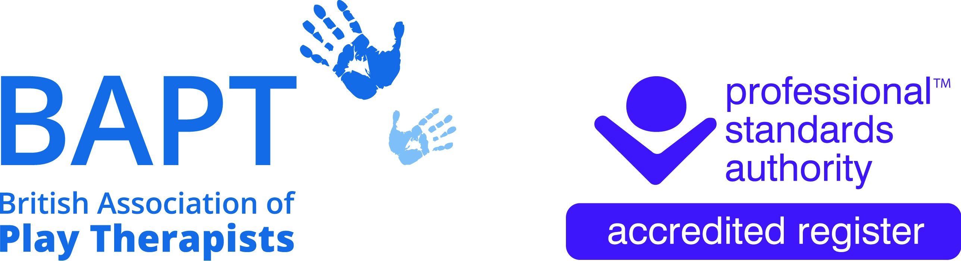 | The British Association of Play Therapists
 |  |  | Tel: | 07955 204068
 |  |  | Email: | info@bapt.uk.com

International Professional Application Form


This form has been designed to ensure that the BAPT Membership Sub-Committee obtain all the information they need to reach the correct decision. By carefully answering each question you will avoid the delay which occurs when we have to ask for information which has been omitted. A £10 administrative fee is required to process all applications for membership.

Q1 | Surname:
 | First Name(s):
 | Title:
 | Date of Birth: |  |  |  |  |  | Membership No:
 |  |  |  |  |  |  | (Present and/or Past)
 | Previous Surname, if any:

Q2 | Address:
 | Country |  | Postcode/Zip Code

Telephone:
Home: |  | Work

Email: | Home: |  | Work

Q3 | What qualifications do you hold or expect to obtain at the end of your present period of study? Please give them in date order, starting with the first.
Award (B.Sc, MA, Postgraduate Dip) |  | Title of course | Name of University or College | Name of awarding body, if different | Dates (give months and year)  Expected
 |  |  |  |  | Start | Completed
Please send a copy of your Degree/MA with your application.

Q4 | Please list the principal appointments you have held. Please list them in date order, starting with the first. Indicate your current appointment.

Job Title or Occupation | Employer Name & Address | Date From | Date To

Q5 | What Professional Associations/ Organisations are you registered with?

Q6 | Specialty Areas or Certifications:

Q7 | Primary Theoretical Orientation:

Q7 | Do you provide Supervision and/or Consultation | Yes |  | No

 | Type of Supervision and/or Consultation Offered | Face to Face
 |  | Distance
 |  | None

Q8 | Do you possess an up-to-date and clear Police Check? |  | Yes |  |  | No
 | Please send a copy of your certificate with your application

Q9 | I am covered by Professional Indemnity and Public Liability Insurance? |  | Yes |  |  | No
 | Please send a copy of your policy with your application

Q10 | Additional Languages spoken:

Q11 | Declaration for International Professional Applicant

I Confirm that:

- I do not have a criminal record that may prejudice the interests of children.
- I have not been dismissed from employment on the grounds of professional misconduct.
- I do not have any health problems or issues that may affect my ability to practise safely and effectively.
- If my application is successful, I will keep BAPT informed of any changes to my circumstances, either professionally or in relation to my personal character (including any conviction or caution that I am required to disclose).
- I have not been refused membership of a professional body or register in a related field on the grounds of professional misconduct.
- I am covered by Professional Indemnity and Public Liability insurance either: *Personally OR by my *Employers Policies (*Please delete as appropriate). Please submit a copy of your Insurance Policy with this application form.
- The information detailed in this membership application form is true to the best of my knowledge and does not contain any false or misleading information regarding my experience, qualifications, practice, membership or identity.
Please note that this declaration is a ‘CONDITION OF MEMBERSHIP’ and that the information provided is required to be accurate and up to date. Therefore, if you cannot confirm any of the above statements, please advise details on a separate sheet. We will contact you to discuss further but please note that failure to comply with these requirements may result in your membership application being rejected.

Signature:
Full Name:
Date:

Payment of Fee:

Payments to be made directly to the following BAPT account; please ensure your full name is used as the reference for the payment.

HSBC
Payee: British Association of Play Therapists
Sort code: 40-30-24
Account no: 41808591
Reference: Your Full Name

International Professional Application Checklist

- I have paid the £10 administrative fee. Yes/No

- I have paid the £70 International Professional fee. Yes/No

- I have enclosed evidence that I have successfully completed a Yes/No
Play Therapy training course.

- I have enclosed a copy of my up-to-date Police Check Yes/No
(must be less than 3 years old from date of issue).

- I confirm that I either have my own *Professional Indemnity Insurance Yes/No
OR *I am covered for Professional Indemnity by my Employer
(*please delete as appropriate)

Policy Number:

Insurer:

Please send a copy of your Insurance Policy with your application.

- I have completed all appropriate questions on my Application Form. Yes/No

- I have signed and dated the International Professional Declaration. Yes/No

If you cannot confirm any of the above statements, please advise details on a separate sheet. We will contact you to discuss further but please note that failure to comply with these requirements may result in your membership application being rejected.

Please share links below to your Play Therapy related social media profiles so that the BAPT Social Media Team can follow, engage, promote and share your posts.

Equality & Diversity Monitoring Questionnaire

1. Gender:
Please tick as appropriate

Male |  |  | Female
Intersex |  |  | Non-Binary
Prefer to Self-Describe |  |  | Prefer not to say
Other

Is the gender you identify with the same as your gender registered at birth?
Please tick as appropriate:

Yes |  |  | No
Prefer not to say

2. Age:
Please tick as appropriate:

Under 25 |  |  | 25-34
35-44 |  |  | 45-54
55-64 |  |  | 65 or above
Prefer not to say

3. What is your ethnicity? Ethnic origin is not about nationality, place of birth or citizenship. It is about the group to which you perceive you belong.
Please tick as appropriate:

White |  |  | Black/African/Caribbean/Black British
Asian/Asian British |  |  | Mixed/Multiple ethnic groups
Prefer not to say |  |  | Other

4. What is your ethnicity? Ethnic origin is not about nationality, place of birth or citizenship. It is about the group to which you perceive you belong.
Please tick as appropriate:

African |  |  | Bangladeshi
British |  |  | Caribbean
Chinese |  |  | English
Gypsy or Irish Traveller |  |  | Indian
Northern Irish |  |  | Pakistani
Scottish |  |  | Welsh
Prefer not to say |  |  | Other

5. What is your sexual orientation?
Please tick as appropriate:

Heterosexual |  |  | Gay
Bisexual |  |  | Asexual
Lesbian |  |  | Pansexual
Undecided |  |  | Prefer not to say
Other

6. Disability
Please tick as appropriate:

Yes |  |  | No
Prefer not to say

7. What is your religious affiliation? My religious beliefs fall within the following category:
Please tick as appropriate:

No religion or belief |  |  | Buddhist
Catholic |  |  | Christian
Hindu |  |  | Jewish
Muslim |  |  | Protestant
Rastafarian |  |  | Sikh
Other |  |  | Prefer not to say

In July 2023 the PSA introduced the new Standard Nine - Equality, Diversity and Inclusion (EDI) Standard to its Standards for Accredited Registers.

BAPT demonstrates its commitment to equality, diversity and inclusion and ensures that its processes are fair and free from unfair discrimination.
a) BAPT’s regulatory functions are underpinned by fairness and equity of access to registrants and service users.
c) BAPT works to promote and enhance EDI by seeking to understand and act on issues affecting the roles registered and service users.

