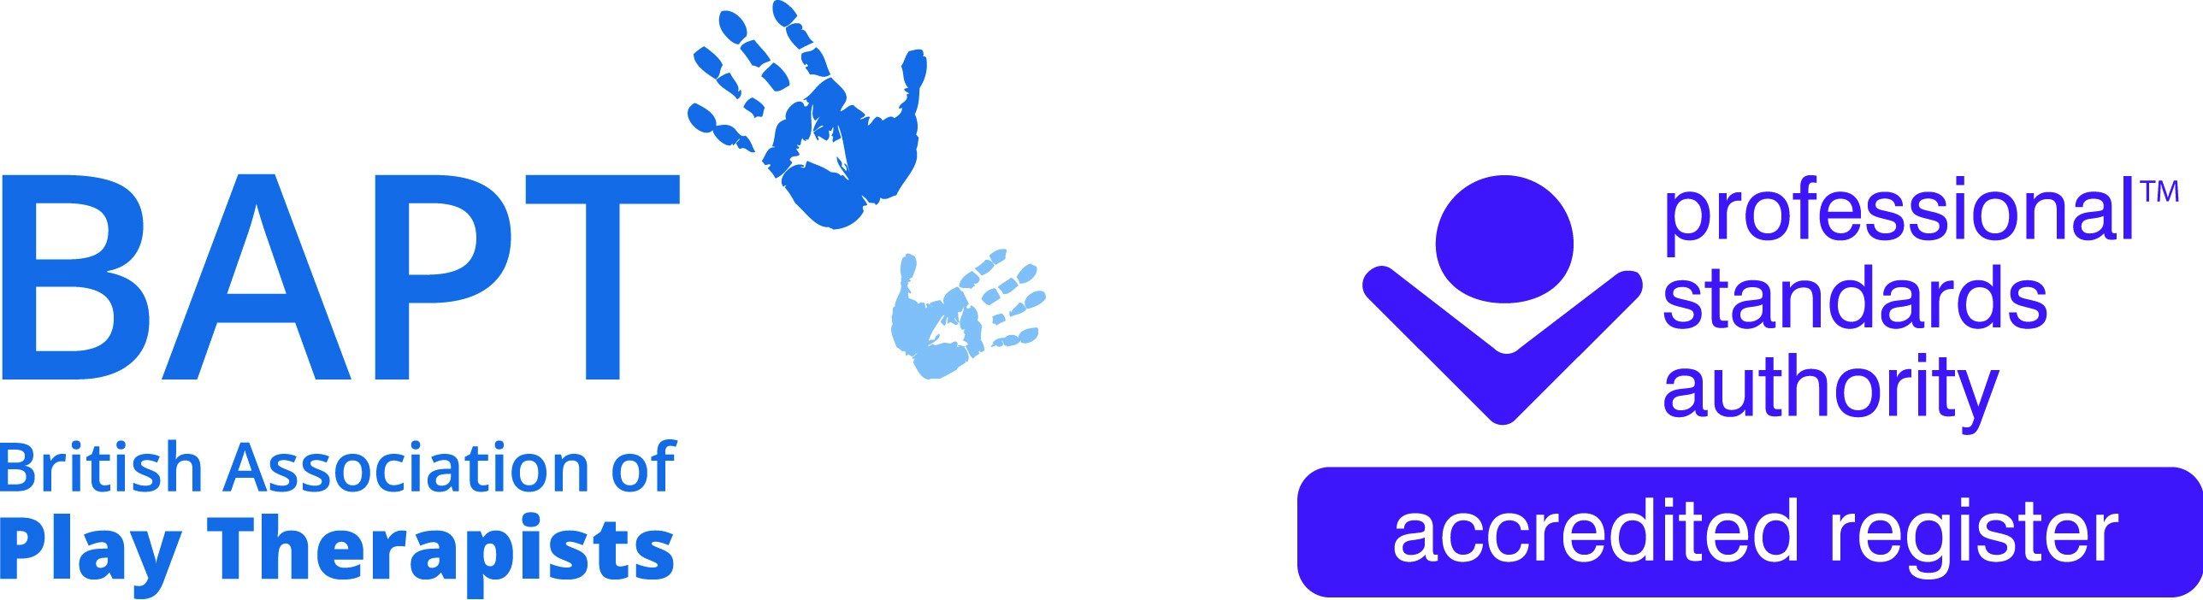 | The British Association of Play Therapists
 |  |  | Tel: | 07955 204068
 |  |  | Email: | info@bapt.uk.com

Application for RETIRED Membership



This form has been designed to ensure that the BAPT Membership Sub-Committee obtain all the information they need to reach the correct decision. By carefully answering each question you will avoid the delay which occurs when we have to ask for information which has been omitted. A £10 administrative fee is required to process all applications for membership.

Q1 | Surname
 | First Names
 | Title
 | Date of Birth |  |  |  |  |  | Membership No
 |  |  |  |  |  |  | (Present and/or Past)
 | Previous Surname, if any

Q2 | Address
 | Postcode
 | Telephone |  | Home |  | Email |  | Home
 |  |  | Work |  |  |  | Work

Q3 | Are you, or have you ever been, a full member of BAPT? (please tick appropriately) |  | Yes |  |  | No

Please advise of your Membership Number if you have been or are a BAPT member?

If you are not a current full member in what year did you leave/retire from BAPT?

Q4 | DECLARATION FOR RETIRED MEMBERSHIP APPLICANT
I CONFIRM THAT:

- I do not have a criminal record that may prejudice the interests of children.
- I have not been dismissed from employment on the grounds of professional misconduct.
- I have not been refused membership of a professional body or register in a related field on the grounds of professional misconduct.
- I understand that membership of the Association cannot, in any circumstances, be used as a qualification to practise and agree not to misrepresent my membership status of the British Association of Play Therapists.
- I agree to abide by the criteria defined in the British Association of Play Therapists Ethical Basis of Good Practice in Play Therapy.
- I have fully retired from all paid employment
Or
I am now solely working as a Supervisor.
- The information detailed in this Retired Member application form is true to the best of my knowledge and does not contain any false or misleading information regarding my experience, qualifications, practice, membership or identity.

Your Signature:
Your Full Name:
Date:

RETIRED MEMBERSHIP APPLICATION CHECKLIST

I have paid the £10 administrative fee.
I have paid the Retired Membership Fee of £35.
I have completed all appropriate questions on the Membership Form.
I have signed and dated the Retired Membership Declaration.

Please share links below to your Play Therapy related social media profiles so that the BAPT Social Media Team can follow, engage, promote and share your posts.

PAYMENT OF FEE

Please make payments directly to BAPTs following Bank Account:

Payee: British Association of Play Therapists
Sort Code: 40-30-24
Account Number: 41808591
Reference: Your Name – Membership Number

