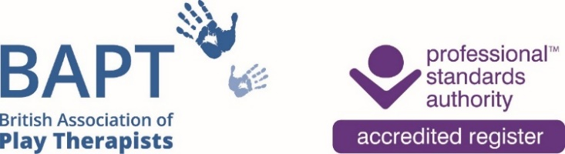**The British Association of Play Therapists**

Tel: 07955-204068

Email: info@bapt.uk.com

**British Journal of Play Therapy Order Form**

The British Journal of Play Therapy is published by the British Association of Play Therapists (BAPT) annually, and is available free to BAPT Full, Student and Retired members, at a discounted price for Associates as well as being open to purchase by libraries, organisations and individual subscribers worldwide.

The journal encourages contributions from a variety of research traditions. The British Journal of Play Therapy is pluralist in orientation, recognising the value of qualitative, quantitative, and mixed method strategies of inquiry.

Play Therapy is an activity which constitutes a specialist domain of practice, and also functions as an adjunct to other occupational roles (for example in health, social services and education). The British Journal of Play Therapy carries papers that are of interest not only to members of BAPT, but also to members of other occupational groups using therapeutic play skills. The journal seeks to be relevant both to a core disciplinary constituency as well as a broader interdisciplinary readership.

**Subscription Type**

|  |  |  |  |  |
| --- | --- | --- | --- | --- |
| Institutional Subscription |  | | Individual Subscription |  |
| Date Subscription Commencing | |  | | |

|  |  |
| --- | --- |
| Individual Journal(s): Journal Volume(s) Required: |  |

**Subscriber Details**

|  |  |
| --- | --- |
| Institution Name (if appropriate) |  |
|  | |
| Your First Name: |  |
|  | |
| Your Surname: |  |
|  | |
| Your Title (please delete and advise as appropriate): | Mr/Mrs/Ms/Miss/Dr/other |
|  | |
| Full Postal Mailing Address: |  |

|  |  |  |  |
| --- | --- | --- | --- |
| Email Address: |  | Contact Number: |  |

**Subscription Fee**

Please tick the correct Annual Subscription rate

|  |  |  |  |
| --- | --- | --- | --- |
| **UK** |  |  |  |
| Institutions (two copies) | £30 |  |  |
|  |  |  |  |
| Individual (one copy) | £17 |  |  |
|  |  |  |  |
| **Europe** |  |  |  |
| Institutions (two copies) | £35 |  |  |
|  |  |  |  |
| Individual (one copy) | £20 |  |  |
|  |  |  |  |
| **North America and International** |  |  |  |
| Institutions (two copies) | £46 |  |  |
|  |  |  |  |
| Individual (one copy) | £23 |  |  |

The above prices include postage.

If you require additional copies then please contact [info@bapt.uk.com](mailto:info@bapt.uk.com) with details.

**How to Pay**

By Bank Transfer to BAPT:

Payee: British Association of Play Therapists

Sort Code: 40-30-24

Account Number: 41808591

Reference: Your Name - Journal

Please email a copy of this Journal Order Form to [info@bapt.uk.com](mailto:info@bapt.uk.com)