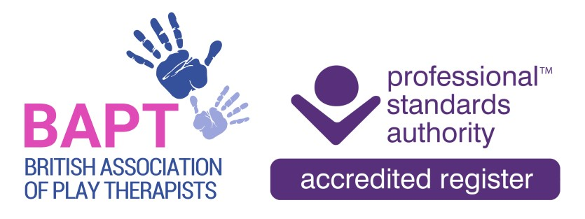 | The British Association of Play Therapists
 |  |  | Tel: | 07955 204068
 |  |  | Email: | info@bapt.uk.com

BAPT Associate Application Form



This form has been designed to ensure that the BAPT Membership Sub-Committee obtain all the information they need to reach the correct decision. By carefully answering each question you will avoid the delay which occurs when we have to ask for information which has been omitted. A £10 administrative fee is required to process all applications.

Q1 | Surname
 | First Names
 | Title
 | Date of Birth |  |  |  |  |  | Membership No
 |  |  |  |  |  |  | (Present and/or Past)
 | Previous Surname, if any

Q2 | Address
 | Postcode

Telephone:
Home: |  | Work

Email: | Home: |  | Work

Q3 | Is this the first application you have ever made to BAPT for any type of membership? |  | Yes |  |  | No

Q4 | DISCLOSURE  Expulsion from another professional body, having been the subject of a disciplinary review by another professional body, including an employer, or having been convicted of a criminal offence is not necessarily a bar to membership of BAPT. However, failure to disclose any such information, or false declarations, may result in a refusal or termination of membership.  To assist with your renewal please ensure that you provide sufficient information in relation to your declaration together with any relevant documentary evidence where applicable. All declarations made may require consideration by the Professional Conduct Panel.  If you have ticked 'Yes' to any of the above, please provide a full and comprehensive signed statement including details of the circumstances surrounding the disclosure, and the outcome if known.  DECLARATION
  Do you have a conviction which is not spent under the Rehabilitation of Offenders Act 1974? | Yes/No
  Have you ever been struck off/ erased/ removed or suspended from membership of any professional body or register on the grounds of professional misconduct? | Yes/No
  Have you ever been refused membership/ registration by a professional body or register on the grounds of professional misconduct? | Yes/No
  Have you ever been the subject of any civil claim brought against you, other disciplinary action, investigation, proceeding or enquiry? | Yes/No
  Are you currently or likely to be the subject of any disciplinary action, investigation, proceeding or enquiry? | Yes/No
  Are there any other factors which could call into question your suitability for membership? | Yes/No
I CONFIRM THAT:

- I do not have a criminal record that may prejudice the interests of children.
- I am not currently, or likely to be, the subject of any disciplinary action, investigation, proceeding or enquiry.
- I have not been dismissed from employment on the grounds of professional misconduct.
- If my application is successful, I will keep BAPT informed of any changes to my circumstances, either professionally or in relation to my personal character (including any conviction or caution that I am required to disclose).
- I have not been refused membership of a professional body or register in a related field on the grounds of professional misconduct.
- I understand that being an Associate of the British Association of Play Therapists cannot, in any circumstances, be used as a qualification to practise and agree not to misrepresent my status as an Associate of BAPT.
- The information detailed in this Associate application form is true to the best of my knowledge and does not contain any false or misleading information.

Please note that this disclosure and declaration is a ‘CONDITION OF MEMBERSHIP’ and that the information provided is required to be accurate and up to date. Therefore, if you cannot confirm any of the above statements, please advise details on a separate sheet. We will contact you to discuss further but please note that failure to comply with these requirements may result in your membership application being rejected.

Your Signature:
Your Full Name:
Date:

FEE PAYMENT

- Annual fee £55 – Membership year for ALL members is 1st October to 30th September – if you are applying after 1st April then a 50% reduction in fee applies.

- Administration Fee £10 - a one-off fee to process this application.

JOURNAL SUBSCRIPTION

The British Journal of Play Therapy is published annually by the British Association of Play Therapists and encourages contributions from a variety of research traditions. The British Journal of Play Therapy is pluralist in orientation, recognising the value of qualitative, quantitative and mixed method strategies of inquiry.

- I would like to include one copy of The British Journal of Play Therapy and have added £11.50 to my payment. (£13.50 for European overseas Associates/ £15.50 for North America and International overseas Associates)

Total fee I am paying £

Payment of Fee

Payments to be made directly to the following account; please ensure your full name and/or membership number, if an existing member, are used as the reference for this payment.

HSBC
Payee : British Association of Play Therapists
Sort Code: 40-30-24
Account Number: 41808591
Reference: Your Name – Membership Number

