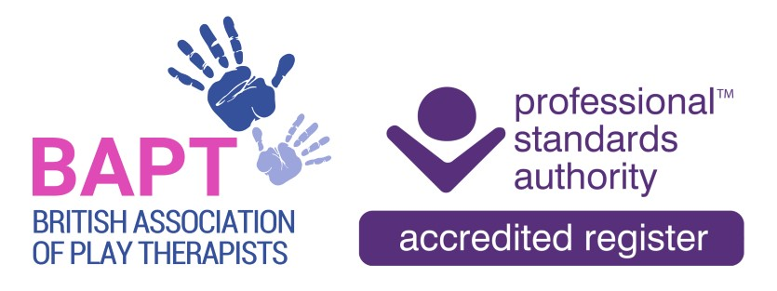 | The British Association of Play Therapists
 |  |  | Tel: | 07955-204068
 |  |  | Email: | info@bapt.uk.com
Application for STUDENT Membership



This form has been designed to ensure that the BAPT Membership Sub-Committee obtain all the information they need to reach the correct decision. By carefully answering each question you will avoid the delay which occurs when we have to ask for information which has been omitted. A £10 administrative fee is required to process all applications for membership.

Q1 | Surname:
 | First Name(s):
 | Title:
 | Date of Birth: |  |  |  |  |  | Membership No:
 |  |  |  |  |  |  | (Present and/or Past)
 | Previous Surname, if any:

Q2 | Address:
 | Postcode:

Telephone:
Home: |  | Work

Email: | Home: |  | Work

Q3 | Is this the first application you have ever made to BAPT for any type of membership? |  | Yes |  |  | No

Q4 | Do you possess an up-to-date and clear Enhanced DBS/PVG Disclosure? |  |  |  | Yes |  |  | No
 | Please send a copy of your certificate you’re your application.
DBS/PVG Number:
Date of Issue:
My above DBS is on the Update Service and |  | Yes |  |  |  | No
I give BAPT permission to check it online.

Having an up-to-date DBS/PVG certificate for Play Therapy work is a requirement of membership. On application for membership a valid DBS/PVG check of less than 3 years is required by BAPT and at each subsequent renewal confirmation of a valid DBS/PVG check is a requirement i.e. DBS/PVG certificate number and date of issue will be required together with a copy of the certificate. If the date of issue is more than 3 years previously, a new DBS/PVG certificate will be required unless the member has subscribed to the DBS update service whereby the certificate can be re-checked as required.

Q5 | Training Details
 | Are you currently registered on a BAPT accredited Play Therapy training programme? |  | Yes |  |  |  | No
 | Which training institution are you studying with?  (you will need to provide evidence of your attendance on this programme – see checklist) |  |  | Roehampton University |  |  |  | University of South Wales
 |  |  |  | WithKids/Queen Margaret University
 | When did you start the Play Therapy training programme?  (please give month and year) |  |  |  | Month |  |  |  | Year
 | What is the intended completion date for the Play Therapy training programme?  (please give month and year) |  |  |  | Month |  |  |  | Year

Q6 | DISCLOSURE  Expulsion from another professional body, having been the subject of a disciplinary review by another professional body, including an employer, or having been convicted of a criminal offence is not necessarily a bar to membership of BAPT. However, failure to disclose any such information, or false declarations, may result in a refusal or termination of membership.  To assist with your renewal please ensure that you provide sufficient information in relation to your declaration together with any relevant documentary evidence where applicable. All declarations made may require consideration by the Professional Conduct Panel.  If you have ticked 'Yes' to any of the above, please provide a full and comprehensive signed statement including details of the circumstances surrounding the disclosure, and the outcome if known.  DECLARATION
  Do you have a conviction which is not spent under the Rehabilitation of Offenders Act 1974? | Yes/No
  Have you ever been struck off/ erased/ removed or suspended from membership of any professional body or register on the grounds of professional misconduct? | Yes/No
  Have you ever been refused membership/ registration by a professional body or register on the grounds of professional misconduct? | Yes/No
  Have you ever been the subject of any civil claim brought against you, other disciplinary action, investigation, proceeding or enquiry? | Yes/No
  Are you currently or likely to be the subject of any disciplinary action, investigation, proceeding or enquiry? | Yes/No
  Is your fitness to practise impaired for any reason including health or personal circumstances? | Yes/No
  Are there any other factors which could call into question your suitability for membership? | Yes/No
I confirm that:

- I do not have a criminal record that may prejudice the interests of children.
- I am not currently, or likely to be, the subject of any disciplinary action, investigation, proceeding or enquiry.
- I have not been dismissed from employment on the grounds of professional misconduct.
- I have not been refused membership of a professional body or register in a related field on the grounds of professional misconduct.
- I have read and agree to abide by the criteria defined in the British Association of Play Therapists Ethical Basis of Good Practice in Play Therapy.
- I am aware of and remain up to date with current and relevant issues in Play Therapy practice, including safe working practice within current Covid19 guidance and regulations, and apply learning from them to my practice where appropriate.
- I am up to date with my safeguarding practice and apply this knowledge appropriately within my work. I have provided proof of my Safeguarding Training.
- I am up to date and comply with current GDPR legislation/requirements.
- The enclosed passport sized photo represents a true likeness to the applicant detailed in this Application Form.
- I am covered by Professional Indemnity and Public Liability insurance either: *Personally OR by my *Employers Policies (*Please delete as appropriate) I have provided a copy of my insurance policy/certificate.
- The information detailed in this membership application form is true to the best of my knowledge and does not contain any false or misleading information regarding my experience, qualifications, practice, membership or identity.
- I understand that Student membership of the Association cannot, in any circumstances, be used as a qualification to practise and agree not to misrepresent my membership status of the British Association of Play Therapists.

Signature:
Full Name:
Date:

Q7 | STUDENT MEMBERSHIP APPLICATION CHECKLIST  This completed form and documents should be emailed to info@bapt.uk.com
 | I have Paid the initial £10 administrative fee
 | I have Paid the Student Membership Fee of £38
 | I have enclosed a copy of my DBS/PVG certificate
 | I have enclosed confirmation of attendance on a validated training course (i.e. letter of acceptance from the relevant university)
 | I have enclosed a copy of my Safeguard training certificate
 | I have enclosed a passport style photo in .jpg format
 | I have signed and dated the Student Membership Declaration
I confirm that I have *my own Professional Indemnity insurance OR
*I am covered for Professional Indemnity by my Employer. (please delete as appropriate)

Policy number:
Insurer:

Please send a copy of your Insurance Policy with your application.

If you cannot confirm any of the above statements, please advise details on a separate sheet. We will contact you to discuss further but please note that failure to comply with these requirements may result in your membership application being rejected.

Please share links below to your Play Therapy related social media profiles so that the BAPT Social Media Team can follow, engage, promote and share your posts.

Payment of Fee:

Please pay your Membership Fee and Administration Fee directly to the following account:

HSBC
Payee: British Association of Play Therapists
Sort code: 40-30-24
Account no: 41808591
Reference: Your Full Name

